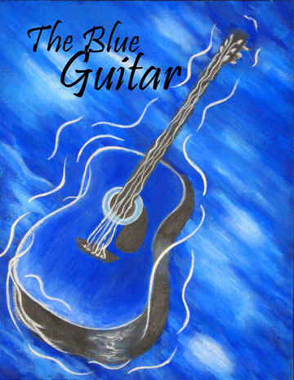

ASU Kurdish Youth Club and Arizona Consortium for the Arts present

2nd annual Blue Guitar Festival of the Arts at ASU West Campus

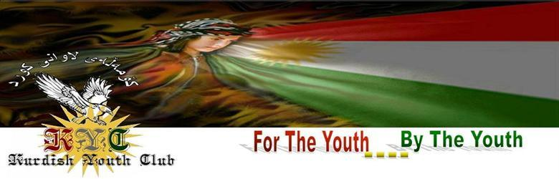
ASU Kurdish Youth Club



Date: Sunday, April 18, 2010
Time: 12pm - 5pm
Location: Arizona State University West, La Sala, 4701 W Thunderbird Rd, Glendale, AZ 85306.
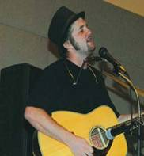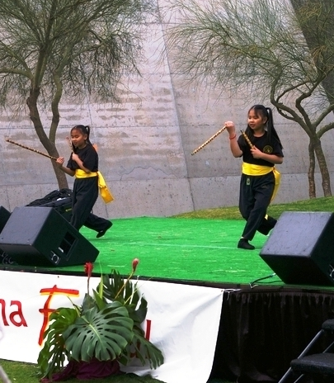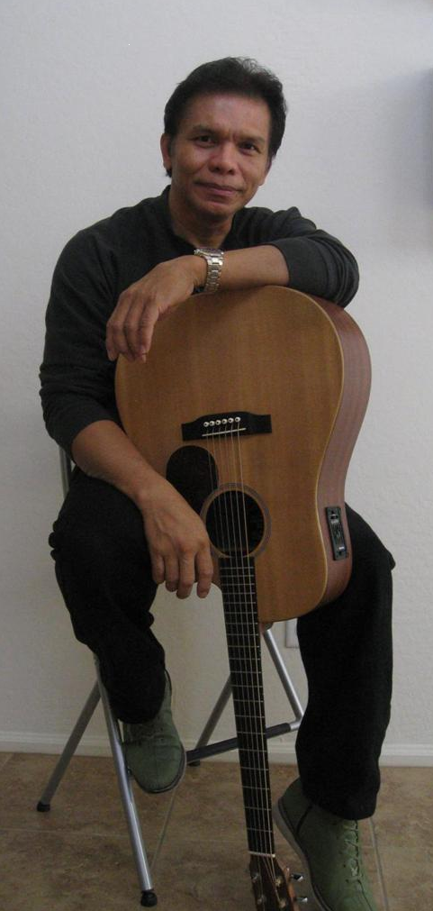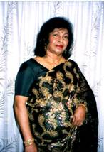
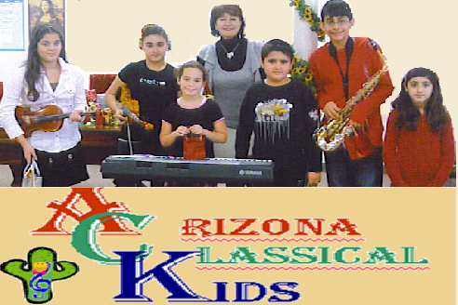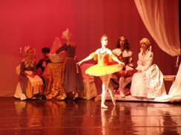
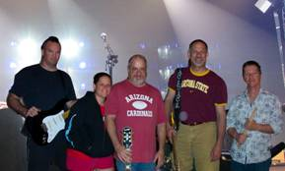
www.artizona.org - www.theblueguitarmagazine.org - www.kurdishyouthclub.com
The festival will include performances by the “Arizona Classical Kids” Musicians, Arizona School of Classical Ballet Students, a presentation of the Filipino Martial Arts by two sisters, Nikki and Grace Tordil, both are sixth-graders at Luke Elementary School. Singer and Acoustic Guitarist Neil Dicks, Opera Singer Maria Restivo, Singer and Acoustic Guitarist Jonathan Gabriel , Singer Edna Elizabeth Abeyasundra, Musician Vincent Alexander Chavez, “SMUDD”, local Rock and Roll Band that will have you rockin’ and rollin’ to your all time favorites, readings from the “Blue Guitar” Magazine and many other artists. There will also be dignitaries and local personalities from the community speaking about the importance of promoting arts and culture in our communities.
This event is FREE to attend
Please come join us for a day of fun festivities.

Arizona Consortium for the Arts

